**CALCULATIONS OF STREAMFLOW AND SEDIMENT CONCENTRATION**

1. **Equations to calculate streamflow (Q, m3 s-1) from flow height (h, m)**

***1a. Eucalyptus saligna* watershed**

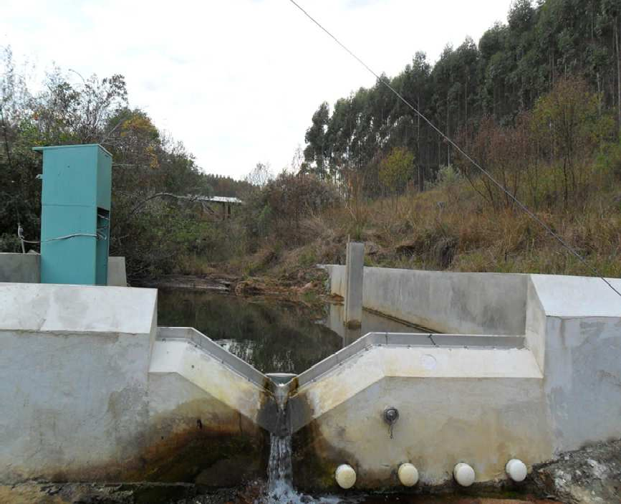

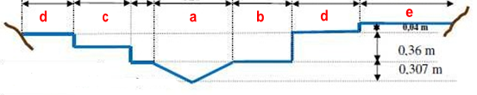

Q = QTS + QIS-1 + QIS-2 + QAS-1 + QAS-2

where Q = total flow; QTS = flow of the main triangular section (a); QIS-1 = flow of the intermediate rectangular section 1 (b); QIS-2 = flow of the intermediate rectangular section 2 (c); QAS-1 = flow of the additional rectangular section 1 (d); and QAS-S = flow of the additional rectangular section 2 (e).

For (a): QTS = 2.40 [h2.50 – (h – 0.307)2.50 ]

##### For (b): QIS-1 = 2.21 (h – 0.307)1.50

##### For (c): QIS-2 = 1.87 (h – 0.507)1.50

##### For (d): QAS-1 = 12.77 (h – 0.667)1.50

##### For (e): QAS-2 = 2.32 (h – 0.707)1.50

***1.b.* Grassland watershed**

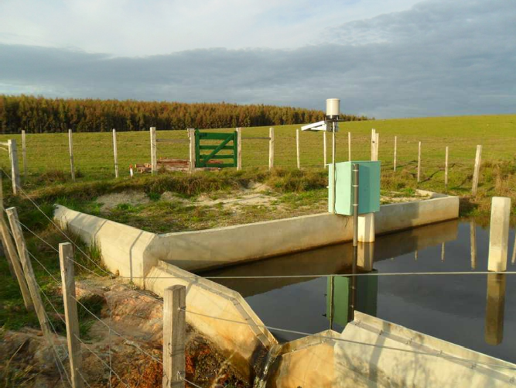

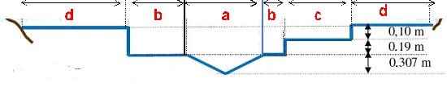

##### Q = QTS + QIS-1 + QIS-2 + QAS

where Q = total flow; QTS = flow of the main triangular section (a); QIS-1 = flow of the intermediate rectangular section 1 (b); QIS-2 = flow of the intermediate rectangular section 2 (c); and QAS = flow of the additional rectangular section (d).

##### For (a): QTS = 2.40 [h2.50 – (h – 0.307)2.50 ]

##### For (b): QIS-1 = 3.16 (h – 0.307)1.50

##### For (c): QIS-2 = 5.50 (h – 0.497)1.50

##### For (d): QAS = 12.68 (h – 0.597)1.50

1. **Equations to calculate suspended sediment concentration (SSC, mg L-1) from turbidity sensor value (mA)**

***2a. Eucalyptus saligna* watershed**

SSC = 1.716 x mA – 41.156

***2.b.* Grassland watershed**

SSC = 3.393 x mA – 114.360